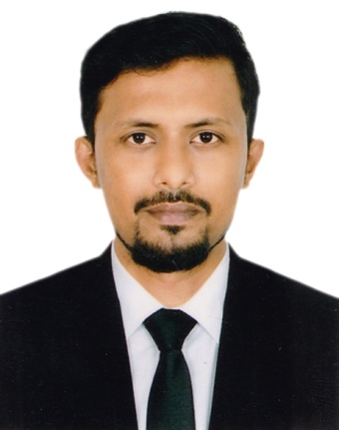

**Sk. A.H.M. Arefin**

10/4 Jafrabad road, Rayer bazar, Dhaka

Mob : +8801718-723873

Email: arefinshovonbd@gmail.com

**Career Objective**

Seeking career in a reputed company where there are sample scopes to prepare as a professional. I also expect to work with a company where I will be able to expose myself to every opportunity through a quality and growth oriented job.

Provide the knowledge, Skill, Expertise and effort in various qualitative applications.

Intend to work in a challenging and competitive field of banking & multinational company also showing strong sense of responsibility, dignity of works and devotion for building a bright career and developing the organization.

**Experience:**

**1. SCHEMA Limited**

Rohomenia International Complex (7th Floor)

28/1/C Toyenbee Circular Road, Dhaka-1000.

**Designation**: Specialist, Receivable Resolution

**Duration**: September 01, 2019 to till now.

**Responsibilities:** Credit Recovery, lead debt collection Team**.**

**2. The City Bank Ltd.**

Al-Razi Complex (16th Floor)

166-167, Shaheed Syed Nazrul Islam Sarani, Purana Paltan, Dhaka-1000.

**Designation**: Trainee Product Marketing Officer

**Duration**: May 13, 2019 to August 31, 2019

**Responsibilities:** Retail sales **(**Personal loan, Home loan, Credit card etc)

**3. Peoples Radio 91.6 fm**

Gulshan 2 , Dhaka, 41 DIT II Cir,

Dhaka 1212, Bangladesh

**Designation**: Jr. Accounts executive

**Duration**: May 10, 2015 to July 2016

**Responsibilities:** Follow up financial activities

**4. Freelance event management**

Dhanmondi 27, Dhaka

**Designation**: Chip executive

**Duration**: Jan 1, 2014 to Present

**Responsibilities:** Communicates on behalf of overall event management activities.

**Academic Qualification:**

**Masters Of Business Administration HRM & Accounting (MBA)**

Year: 2018

University: Uttara University, Dhaka, Bangladesh

Obtained Grade Point: **3.05** (Out of 4)

**Relevant Courses:**

* Leadership, Power and Influence
* Management Information Systems
* HR policy
* Strategic Management
* International Business Management

**Bachelor of Business Administration in Finance & Accounting (BBA)**

Year: 2016

University: Uttara University, Dhaka, Bangladesh

Obtained Grade Point: **2.65** (Out of 4)

**Relevant Courses:**

* Financial Management
* Banking and Insurance
* Accounting Management
* Capital Budgeting
* Cost Accounting
* Financial Research

# Higher Secondary Certificate (HSC)

Year: 2010

Group: Business studies

Institution: Government Commercial College

Board: Dhaka

Obtained Grade: **3.86** (Out of 5)

## Secondary School Certificate (SSC)

Year: 2008

Group: Business Studies

Institution: Kushtia Zilla School Kushtia

Board: Jessore

Obtained Grade: **3.69** (Out of 5)

**Communication Skills :**

* Fluent in English & Bengali-Both verbal & written.
* Proficient in Writing and editing reports.
* Efficient in multimedia presentation.

**Computer Skills :**

* Office Application: Microsoft office (Word, Excel, Power Point, Outlook)
* Network Operating & Internet Access (E-mail, Web Browsing)
* Software Application: nuendo audio software, Pro-tools, Adobe Audition etc.

**Personal Interest :**

* Music, Traveling, Playing Pool, Photography

### General Profile :

**Father’s name** : Sk. Fazle Rab

**Mother’s name** : Mst. Rabeya Khatun

**Date of birth**  : 4th April 1992

**Religion**  : Muslim

**Marital Status** : Married

**Blood Group** : AB + (ve)

**Hight** : 5.10”

**Permanent Address** : 49/1, Sonarbangla Road, Kalisankarpur,Kushtia.

**Nationality** : Bangladeshi by birth

##### Self-Evaluation :

Have quality to familiar quickly with any new working environment and have ability to make environment friendly. Always prefer to work with a team spirit and enjoy learning from others in every single step. Always give the best effort.

**References:**

**1. Mirza Saiem Mahmud**

Additional Deputy Police Commissioner

Detective Branch, Chittagong

Cell: 01769691164

Email:adcdbcmp@gmail.com

**2. SK.A.H.M. Hasan**

Assistant Register

Uttara University, Dhaka

Cell: 01712-691532

Email:skahmhasan@yahoo.com



-------------------------------------

**Sk. A.H.M Arefin**

**Date: 21 -01-2020**